1. “Development of PC’s was a major landmark in 1980s.”

Which of the following is **incorrect** regarding the statement above?

1. Invention of microprocessor enabled the development of the Personal Computer (PC)
2. General people started using computers for their personal work
3. Business organizations started using computers in their business functions to improve efficiency
4. Central Processing Unit (CPU) supported only for batch processing
5. Size, capabilities, and price made it feasible for individual use
6. Office Automation Systems(OAS) are;
7. Developed to increase improved decision making of managers
8. Developed to increase productivity of the office employees
9. Developed to increase the end customer satisfaction
10. Developed to automate only service-based organizations
11. Developed to reduce redundant and waste work
12. Computer Aided Design (CAD) and Computer Aided Manufacturing (CAM) systems are;
13. used in Banking and Financial industries
14. used in Human Resource Management functions
15. used in Product Manufacturing industries
16. used in e-Learning applications domain
17. used in Service oriented organizations
18. Enterprise System is **not** suitable when;
19. Organization needs to keep good intimacy with customers and suppliers
20. Organization needs to get full benefit from globalization
21. Organization needs to use Information systems only to increase productivity of their employees
22. Organization allows their business partners to access their information
23. Organization is having fairly complex and distributed structure

**Mediterranean Shipping Company**

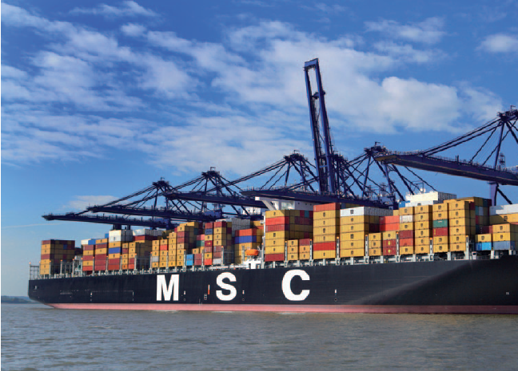

As the second-largest shipping company in the world, MSC’s (Mediterranean Shipping Company) fleet annually transports more than 12 million containers that have to be loaded and cleared in some 270 ports. Handling transport and its associated process chain is complex; it is affected by uncontrollable situations such as bad weather, strikes, etc., and it is accompanied by immense volumes of data and information: certificates of origin, documents of title to goods, way bills, bills of lading, commercial and customs invoices, and packing lists, to name but a few. The central IT system in Geneva has to electronically process and validate more than 300,000 transactions each day.

In the transportation sector, the containers and papers dictate the route and planning because, given the long supply chain, outside influences such as a strike by truck drivers, dockworkers, or customs agents, a storm, missing papers, or an error by the tracking companies, all can result in repeated changes. For this reason, a clear workflow has to be provided that can track and record the current course of the process, and when unplanned changes occur, automatically authorize consistent and logical steps. “Ship transport is just a small part of the entire transport and supply chain. But it is extremely critical. Many customers who trust us with their freight depend on precise and current delivery information for the planning of their company activities,” says Rumen Lilov, eBusiness Development Manager at MSC. “This is why it is important to us that they receive the time status for their delivery. And specifically, from when it is accepted at the port until it is delivered at its destination.”

**Key issues/problems faced by MSC:**

**Problem 1:** **Existing technologies could not meet the requirements.**

The existing database in use at MSC unable to manage the volumes of data, process and validate them in **real- time**, and make them available without delay to the MSC agency network worldwide.

**Problem 2: Existing Information Systems have no clear workflow implemented.**

**Problem 3:** **Inability to provide precise information & tracking/alerting mechanism about freight of MSC customers around the globe.**

**Your task:**

Form groups of five members.

Assume that your team has been appointed as the responsible IS/IT professional consultants by MSC to analyze the current situation in detail.

Apply your knowledge gain through the lecture session-Modern Information Systems and provide a sophisticated IS/IT solution/s for the main problems listed above. You are required to clearly understand the issues and explain how your solution resolve such issues.

Discuss the strategic/competitive advantages that MSC may achieve through your holistic solution.

NOTE: Randomly picked few teams should present their solution in the classroom.

**Answer**

**Problem 1:** **Existing technologies could not meet the requirements.**

They have a central database in Geneva. You may suggest an IS (Such IS is discussed under problem 2 and 3) that has connected to a ***distributed database*** as a solution to handle large volumes. (Discuss advantages of distributed databases.) Since they need to process and validate data in real time, distributed database gives high speed performance.

**Competitive advantage:**

Distributed databases increase the fast retrieval and high information availability. Hence fast query processing leads fast service to the customer. That brings competitive advantage to MSC.

**Problem 2: Existing Information Systems have no clear workflow implemented.**

You may suggest two types of modern information systems here.

1. ***Supply chain management system*** as an Enterprise System.

Highlight the following functions in SCM systems that directly involved with this MSC.

* Warehouse management
* Logistic management
* Transportation management
* Financial planning etc.

1. The same SCM system can be implemented as a **Workflow management system**.

Highlight the following capabilities in WFMSs.

* Assign tasks to people.
* Allow collaboration between people sharing task.
* Retrieve information needed to complete a task e.g. customer details.
* Provide an overview of the status of each task.
* Can be used in conjunction with DIP to provide automated routing of documents.

***Competitive Advantage:***

The above modern IS should be **Web based systems** which has access to this distributed database, from anywhere (270 ports located worldwide) can improve decision making with fast and accurate information. That is how this solution brings **competitive advantage** to the company.

This web based IS that will be implemented in MSC should be able to connect to their customers’ SCM systems to provide precise and current delivery information for the planning of their company activities. It then becomes a real Enterprise System, that connects own IS to business partner’s IS’s crossing all organizational boundaries. ( Relate this to what Rumen Lilov said.)

MSC can deploy their systems on cloud and that helps the company to active competitive advantage mainly reducing the cost. Cloud service can be used for proper backup and recovery to increase the reliability of their data and avoid losses of important data.

**Problem 3:** **Inability to provide precise information & tracking/alerting mechanism about freight of MSC customers around the globe.**

MSC can use object tracking technologies such as RFID and NFC with the support from GPS technology to provide tracking/tracing of their cargo by the customers themselves .

**Competitive advantage:**

That increases the customer satisfaction and helps to have lock-in-customers by increasing their switching cost to the competitors.

-------------------------------------------------

In addition to the 3key issues highlighted, there are other issues also available such as employee strikes and bad weather conditions.

You may suggest a good human resource management system whichembed with a BI tool that can forecast future employee behavior analyzing them today. If human resource can be managed well using a good HR management IS, there will not be such strikes.

Company can use weather forecasting application systems (kind of Expert systems) and take necessary precautions beforehand.

**Competitive advantage:**

If MSC can avoid such cases with the support from IS, that will reduce losses and bring competitive advantage to the company.